**Sampling:**

1. N=3,000 American panelists representative on age, gender, education and geographic location
2. Please provide time used for each screen
3. Please provide information on the following background variables: age, gender, education, geographic location, income and vote choice.

Background / PDL’s:

Gender: (PDL: gender) (sample)

Age: (PDL: age) (Sample)

Region: (PDL: region) (sample)

Race: (PDL: race) (sample)

Education: (PDL: educ) (sample)

Inputstate (PDL: inputstate)

Division (PDL: Division)

Household income: (PDL: faminc_new)

Last election vote choice: (PDL: presvote20post)

**#Intro:**

**Text**

Welcome to this survey conducted by researchers affiliated with the HOPE (How Democracies Cope with COVID-19) research project, directed from leading universities in Denmark.

The survey is about the coronavirus pandemic, leading to widespread transmission of the disease known as COVID-19. Please read carefully every question and instruction. There are no right or wrong answers, but with honesty and by paying attention you can help our understanding of how to best handle the pandemic.

During the survey, you will be presented with information about the COVID-19 epidemic situation in the United States. We have strived to ensure that this information is accurate and reflects the best evidence currently available. The study involves no risks beyond exposure to information that may be uncomfortable to read. This information, however, will be no different from what you may read or see in the regular news.

Your participation in this study is completely voluntary. Your answers are anonymous and will be analyzed exclusively as part of a larger dataset. You can decide to stop filling out the survey or being part of the study at any time. Your decision need not be justified. If you have any questions or concerns, you are welcome to contact Professor Michael Bang Petersen at michael@ps.au.dk.

We appreciate you taking a few minutes to helping science finding ways to overcome the COVID-19 epidemic.

Please click on the arrow in the bottom right corner to confirm that you have read and understood this consent form and that you consent to the processing of your data by the researchers as outlined above.

**#New screen:**

**Text**

On the next screen you will be presented with information about the situation of the COVID-19 epidemic in United States and what you as a citizen need to do. We ask you to consider the information carefully. You will be asked a number of questions about the information on the subsequent screens.

**#New screen:**

**Scripting instructions:**

Randomly present participants with 1 of the 3 following conditions

Splitsample:

1. Group1 🡪 Show Condition 1
2. Group2 🡪 Show Condition 2
3. Group3 🡪 Show Condition 3

**Text - Condition 1 if Group1**

New evidence has demonstrated that the coronavirus has mutated and that several new variants are more infectious. This means that the coronavirus is **more easily transmitted** between people. The evidence also shows that new more infectious variants is **already spreading in United States**. Because of this health authorities may **urge citizens to more strongly adhere** to the guidelines for halting the spread of the coronavirus.

**Text - Condition 2 if Group2**

New evidence has demonstrated that the coronavirus has mutated and that several new variants are more infectious. This means that the coronavirus is **more easily transmitted** between people. The evidence also shows that new more infectious variants is **already spreading in United States**. Because of this health authorities may **urge citizens to more strongly adhere** to the guidelines for halting the spread of the coronavirus.

The graph below shows why stronger measures are needed to **save lives**. The graph illustrates how the number of hospitalized people due to COVID-19 are likely to develop under different circumstances.

The blue curve shows how the current measures are likely to be enough to halter the spread of the normal variant of the coronavirus. Yet, a more infectious virus causes the epidemic to **develop much faster and with more cases**.

With just the current measures, it is likely that the epidemic will follow the red curve: The spread of the new, more infectious variant will cause cases to exceed the capacity of the health care system, leading to **a surge in deaths**.

To avoid this, **stronger measures are needed**. By wearing a face mask and engaging systematically in physical distancing, limiting social contacts, we can flatten the curve and bring down the cases below the capacity of the health care system. By adhering more strongly to the guidelines of the health authorities, we can together bring the epidemic to follow the green curve.

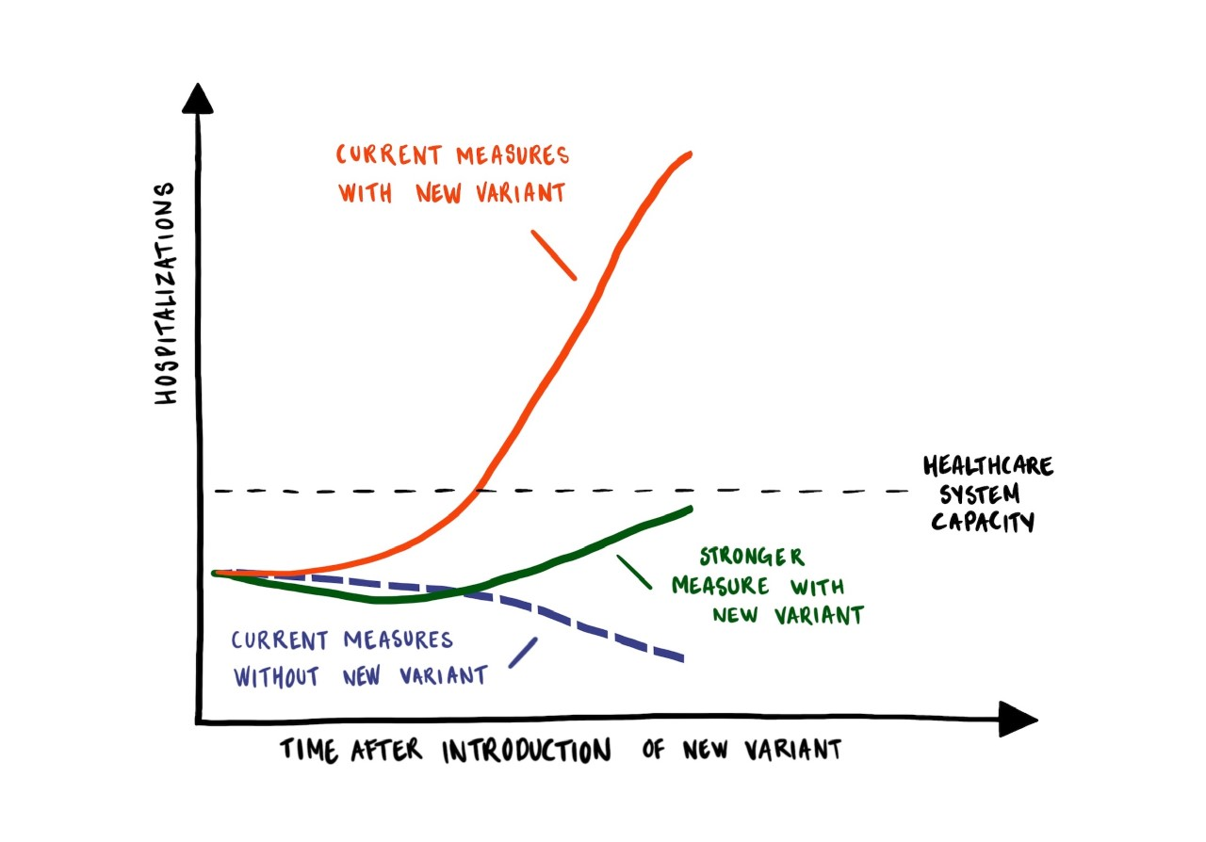

**Text - Condition 3 if Group3**

New evidence has demonstrated that the coronavirus has mutated and that several new variants are more infectious. This means that the coronavirus is **more easily transmitted** between people. The evidence also shows that new more infectious variants is **already spreading in United States**. Because of this health authorities may **urge citizens to more strongly adhere** to the guidelines for halting the spread of the coronavirus.

The graph below shows why stronger measures are needed to **save lives** **by buying** time until the vaccines will effectively bring an end to the epidemic. The graph illustrates how the number of hospitalized people due to COVID-19 are likely to develop under different circumstances.

The blue curve shows how the current measures are likely to be enough to halter the spread of the normal variant of the coronavirus. Yet, a more infectious virus causes the epidemic to **develop much faster and with more cases**.

With just the current measures, it is likely that the epidemic will follow the red curve: The spread of the new, more infectious variant will cause cases to exceed the capacity of the health care system, leading to **a surge in deaths**.

To avoid this, **stronger measures are needed**. By wearing a face mask and engaging systematically in physical distancing, limiting social contacts, we can flatten the curve and bring down the cases below the capacity of the health care system. By adhering more strongly to the guidelines of the health authorities, we can together bring the epidemic to follow the green curve.

Despite this worsening of the epidemic, **optimism is warranted**. The vaccines are here and they are **a game changer**. Our goal is to **buy time** until vaccines against COVID-19 take effect. When vaccines take effect on the epidemic, the epidemic will slow down and the number of cases will fall. Because vaccines will soon take effect, **action is more important than ever**. Without vaccines, those who are saved today because of stronger measures against COVID-19 might have been infected later and might have died later. Because of the vaccines, each person who is saved from COVID-19 today will be **saved for good**.

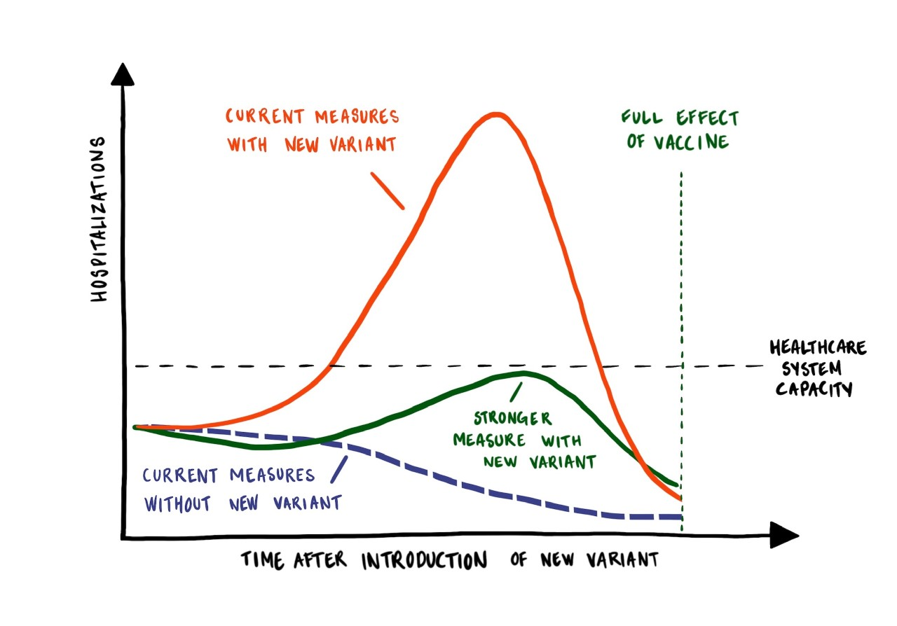

**#New screen:**

**Grid**

**Scripting instruction:**

1. If Group1 don’t INSERT graph
2. If Group2 INSERT graph shown in Condition 2
3. If Group3 INSERT graph shown in Condition 3

[q1] Please indicate how much you agree or disagree with each of the following statements about the information you just saw.

1. The information provided a fearful message
2. The information provided a hopeful message
3. The information clearly explained why new coronavirus variants are a **public health threat**
4. The information clearly explained why people need to **adhere** more strongly to the health authorities' **guidelines** because of new coronavirus variants
5. The information clearly explained how we as a society can **get** safely **through** this pandemic
6. The information clearly explained why **strong measures** are required until vaccines take full effect and drive down infections
7. The information could help others understand why new coronavirus variants are a public health threat
8. The information could help others understand why they need to adhere more strongly to the health authorities' guidelines because of new coronavirus variants
9. The information could help others understand how we as a society can get safely through this pandemic
10. The information could help others understand why strong measures are required until vaccines take full effect and drive down infections
11. The information helped me understand why new coronavirus variants are a public health threat
12. The information helped me understand why I need to adhere more strongly to the health authorities' guidelines because of new coronavirus variants
13. The information helped me understand how we as a society can get safely through this pandemic
14. The information helped me understand why strong measures are required until vaccines take full effect and drive down infections

Scale:

1. Strongly disagree <<p></p>>1
2. 2
3. 3
4. Neither agree nor disagree <<p></p>>4
5. 5
6. 6
7. Strongly agree <<p></p>>7

**#New screen:**

**Single**

[q6] Please recall the text that you read earlier in this survey. We will now ask some further questions about it.

Did the text mention a new public health threat to the United States?

1. Yes, the text mentioned a new variant of the coronavirus that was more infectious
2. Yes, the text mentioned a fully new disease
3. No, the text did not mention a new public health threat to the United States
4. Cannot remember
5. Didn't read the text carefully

**#New screen:**

**Single**

[q7] The text that you read earlier mentioned a new public health threat in the form of a new, more infectious variant of the coronavirus.

According to the text you read has this new variant already been observed in United States?

1. Yes
2. No
3. Cannot remember
4. Didn't read the text carefully

**#New screen:**

**Single**

[q8] Did the text you read include a graph?

1. No, the text I read did not include a graph
2. Yes, the text I read included a graph
3. Cannot remember
4. Didn't read the text carefully

**#End screen:**

**Text**

Thank you for your participation!

We appreciated your honesty and attention as you completed this survey.

For the most up-to-date information about the coronavirus outbreak, please visit: https://www.cdc.gov/coronavirus/2019-ncov/index.html.

Some respondents were presented with a graph that illustrated the development of the pandemic with and without more infectious variants of the coronavirus. We have based this graph on mathematical models that simulates the epidemic. The parameters of the model are based on Denmark, as the infectious variant is already spreading here. Nonetheless, the graph is an illustration and not a certain prediction for how the epidemic will unfold. Also, the different aspects of the graph depend on many different decisions. Hospital capacity can be raised to some extent; measures against the new variants does not just include people's behaviors but also better contact tracing and so forth.

If you have any questions or concerns about this survey, please contact Professor Michael Bang Petersen at michael@ps.au.dk.